Create a new Project – To club all independent modules. Eg. lab035-shopping

* Choose maven archetype
* Change the location
* Choose the archetype option (after catalog)
* Change advanced settings

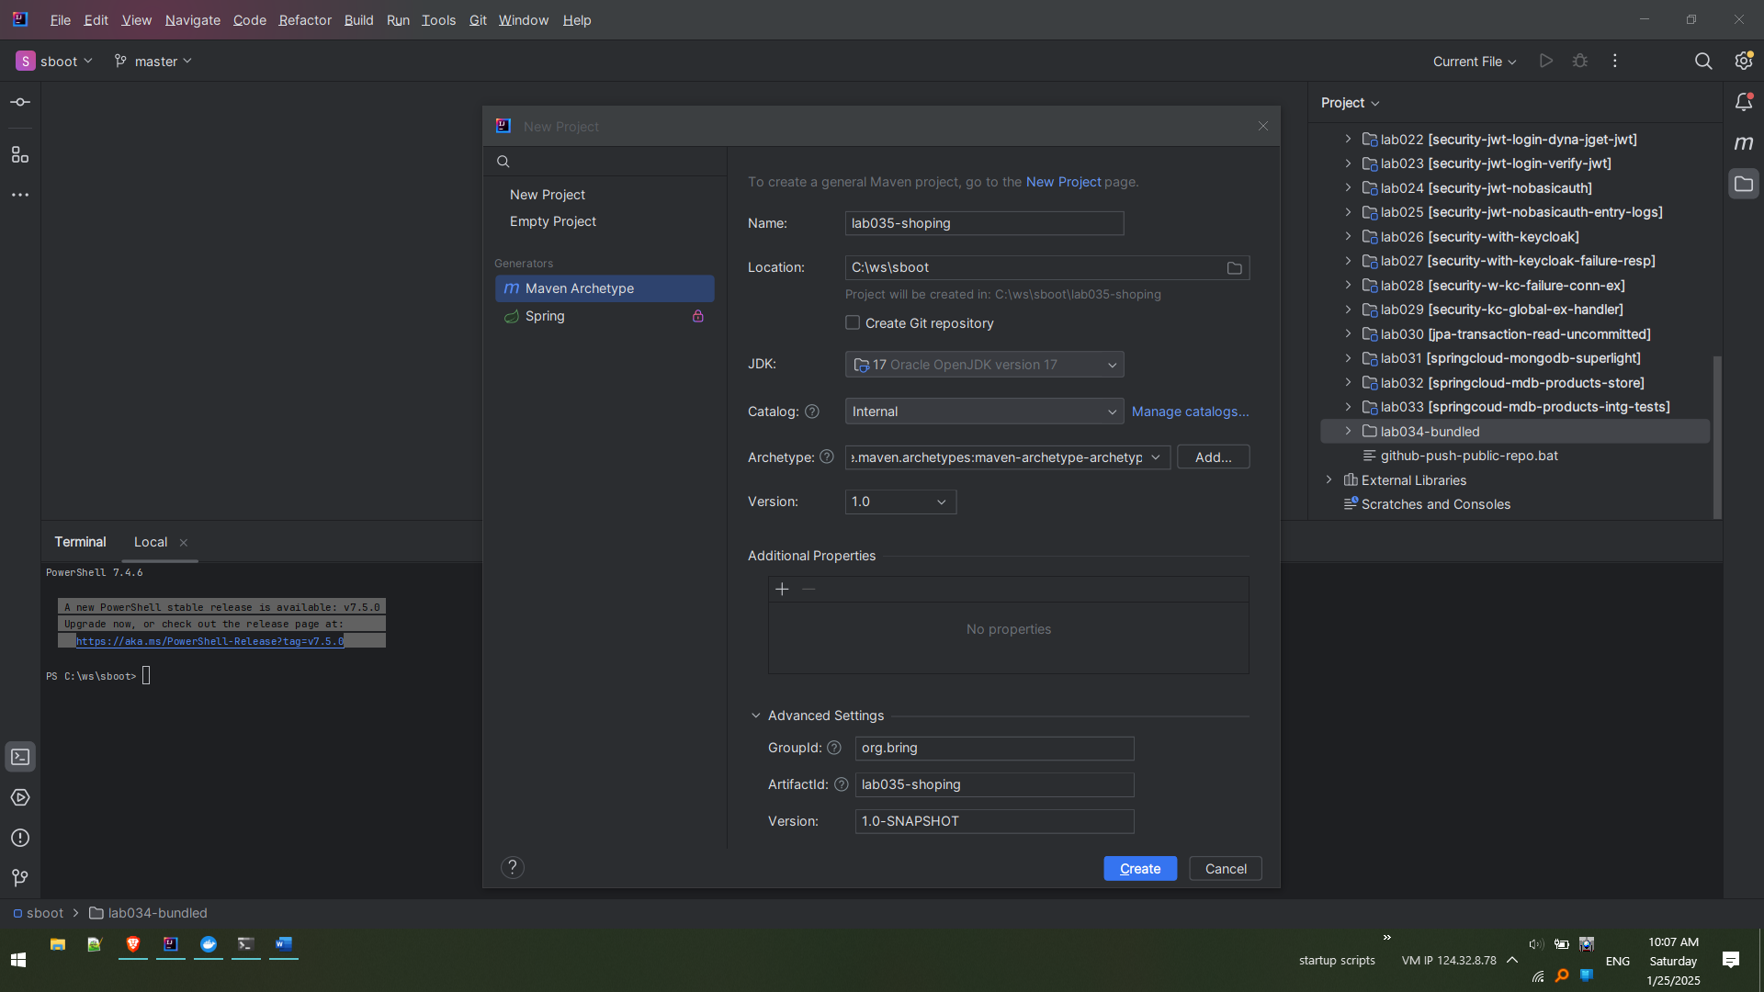

New Project is created

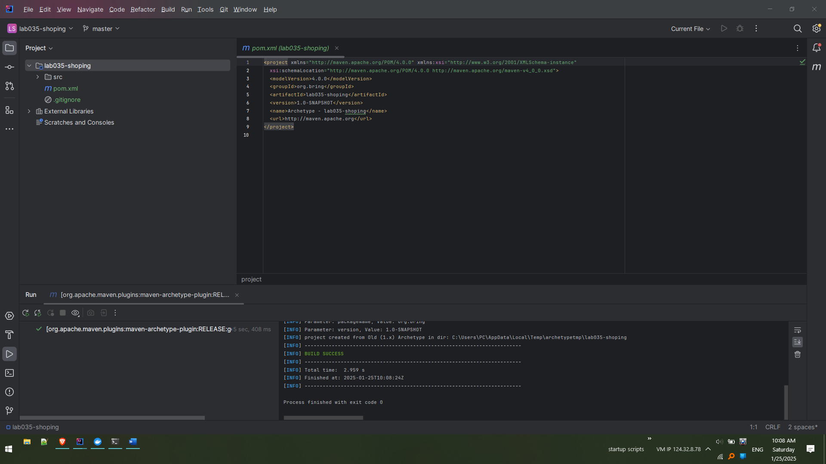

Create new Maven Module – Order Service

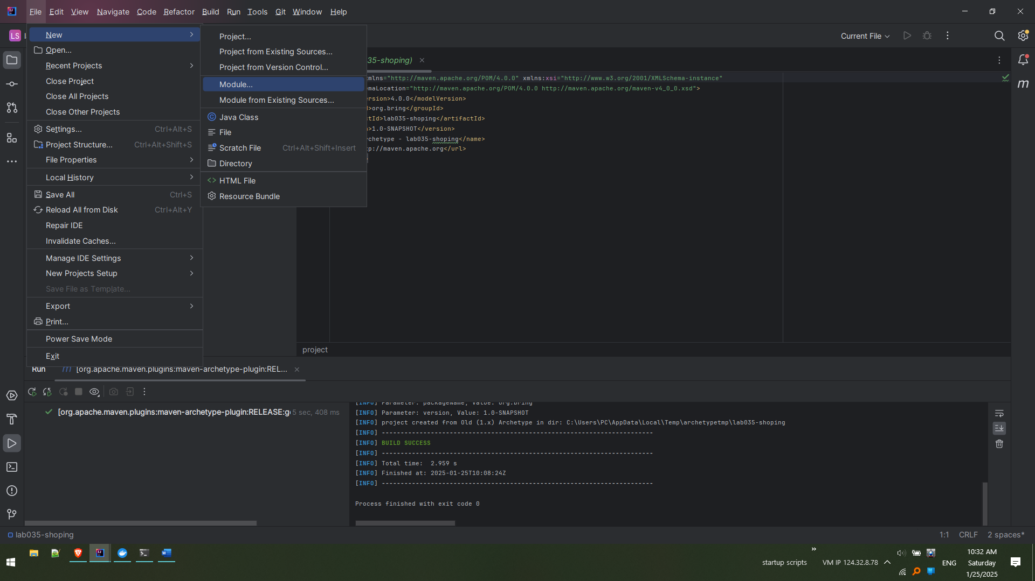

Provide appropriate naming as shown and click ‘create’

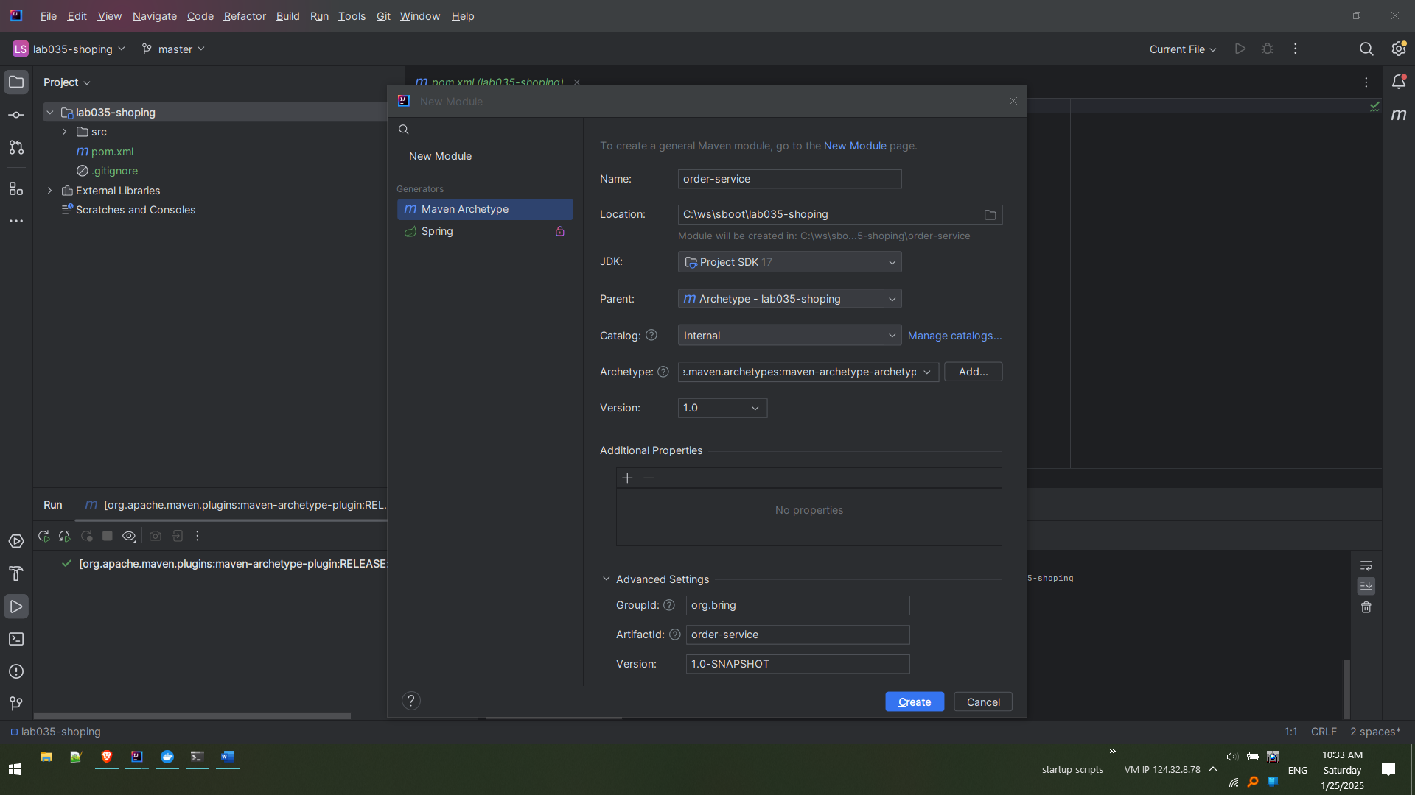

Notice maven module is created and added main project ‘lab035-shopping’

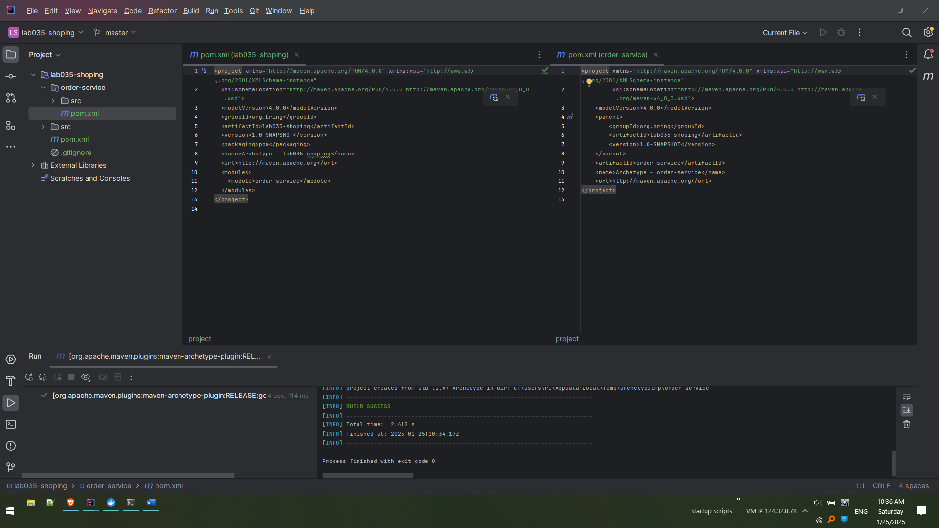

Create new Maven Module – Products Service

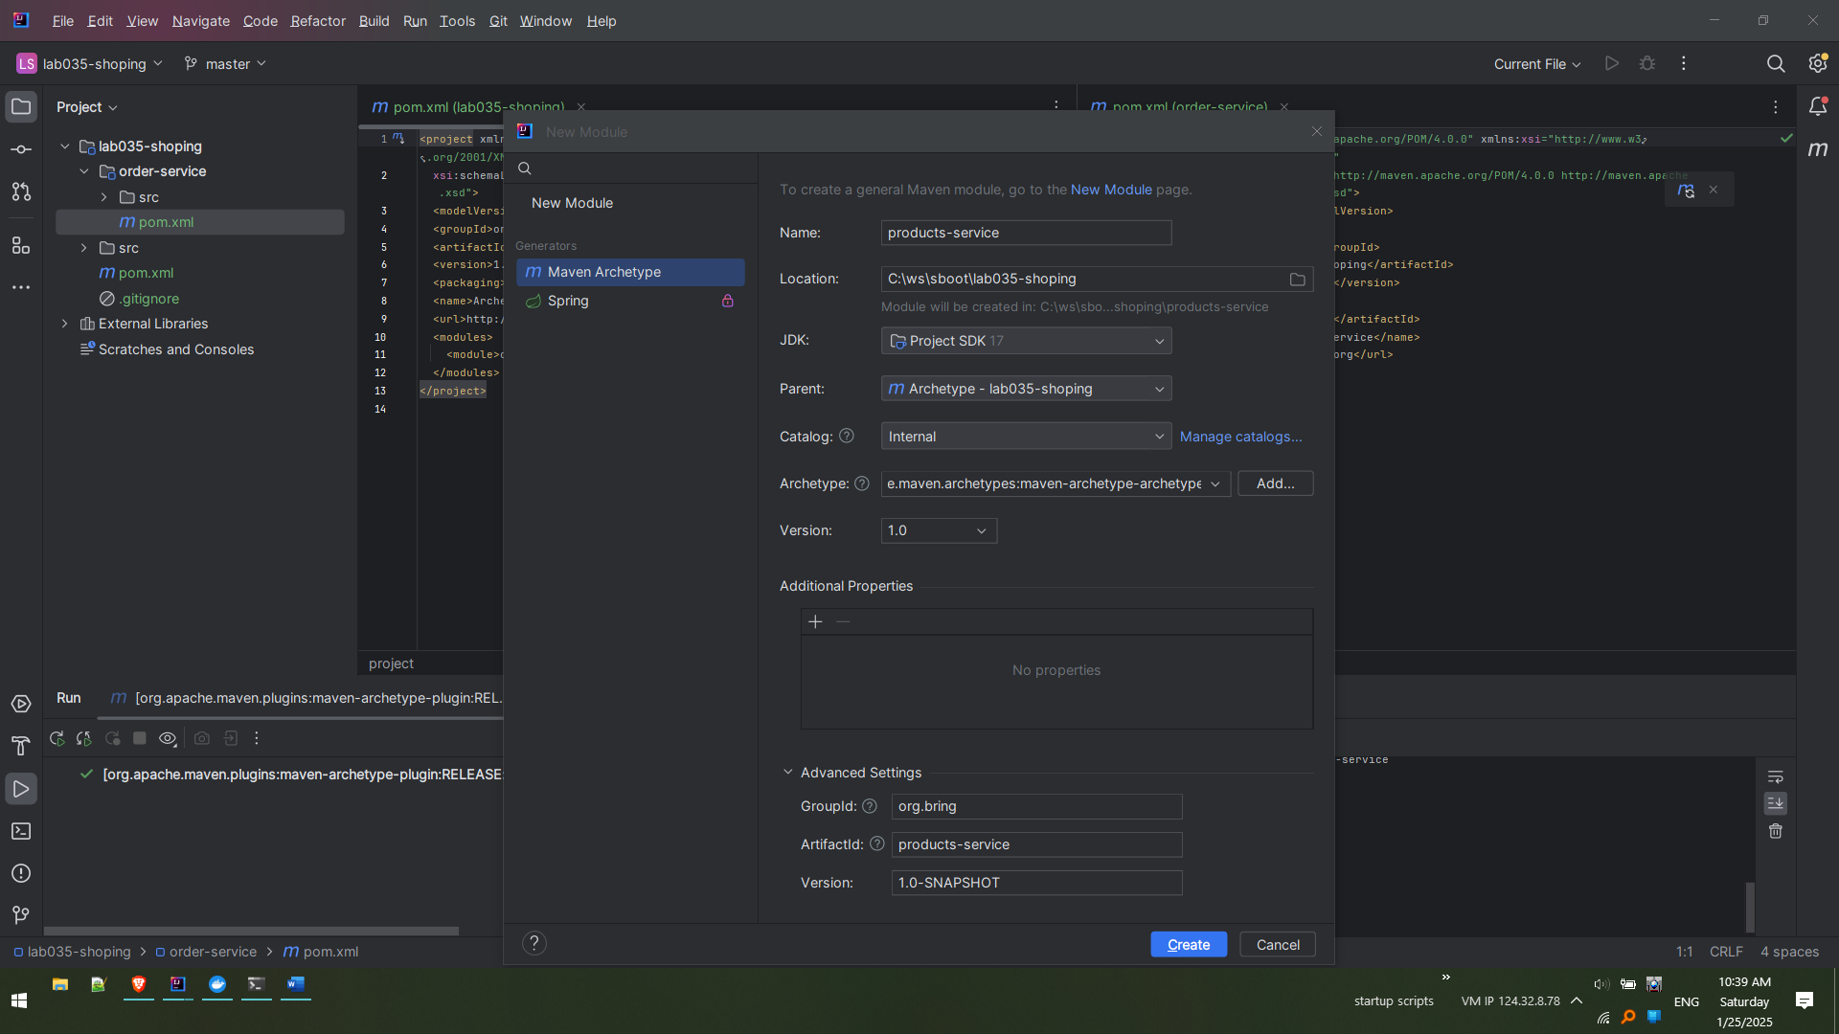

Notice the changes while creation is happenning

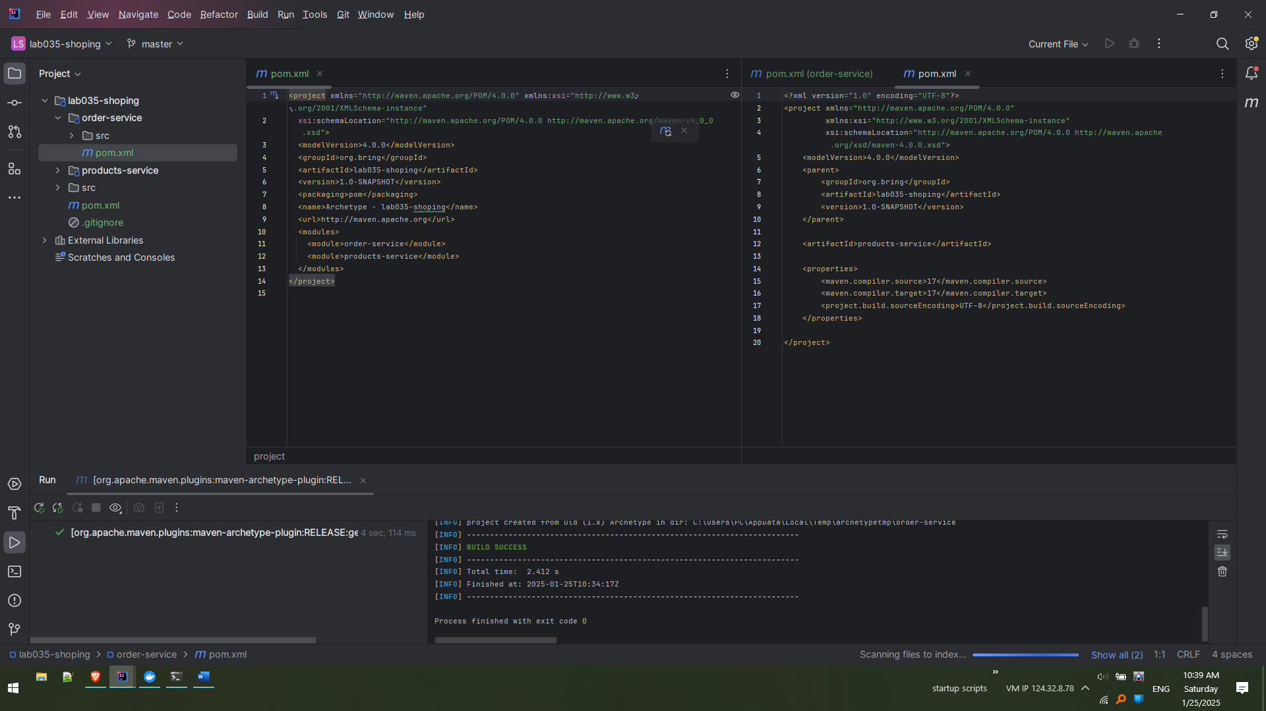

Once the creation is done a new pom.xml is created and also in the parent pom.xml (lab035-shopping) the modules are also added

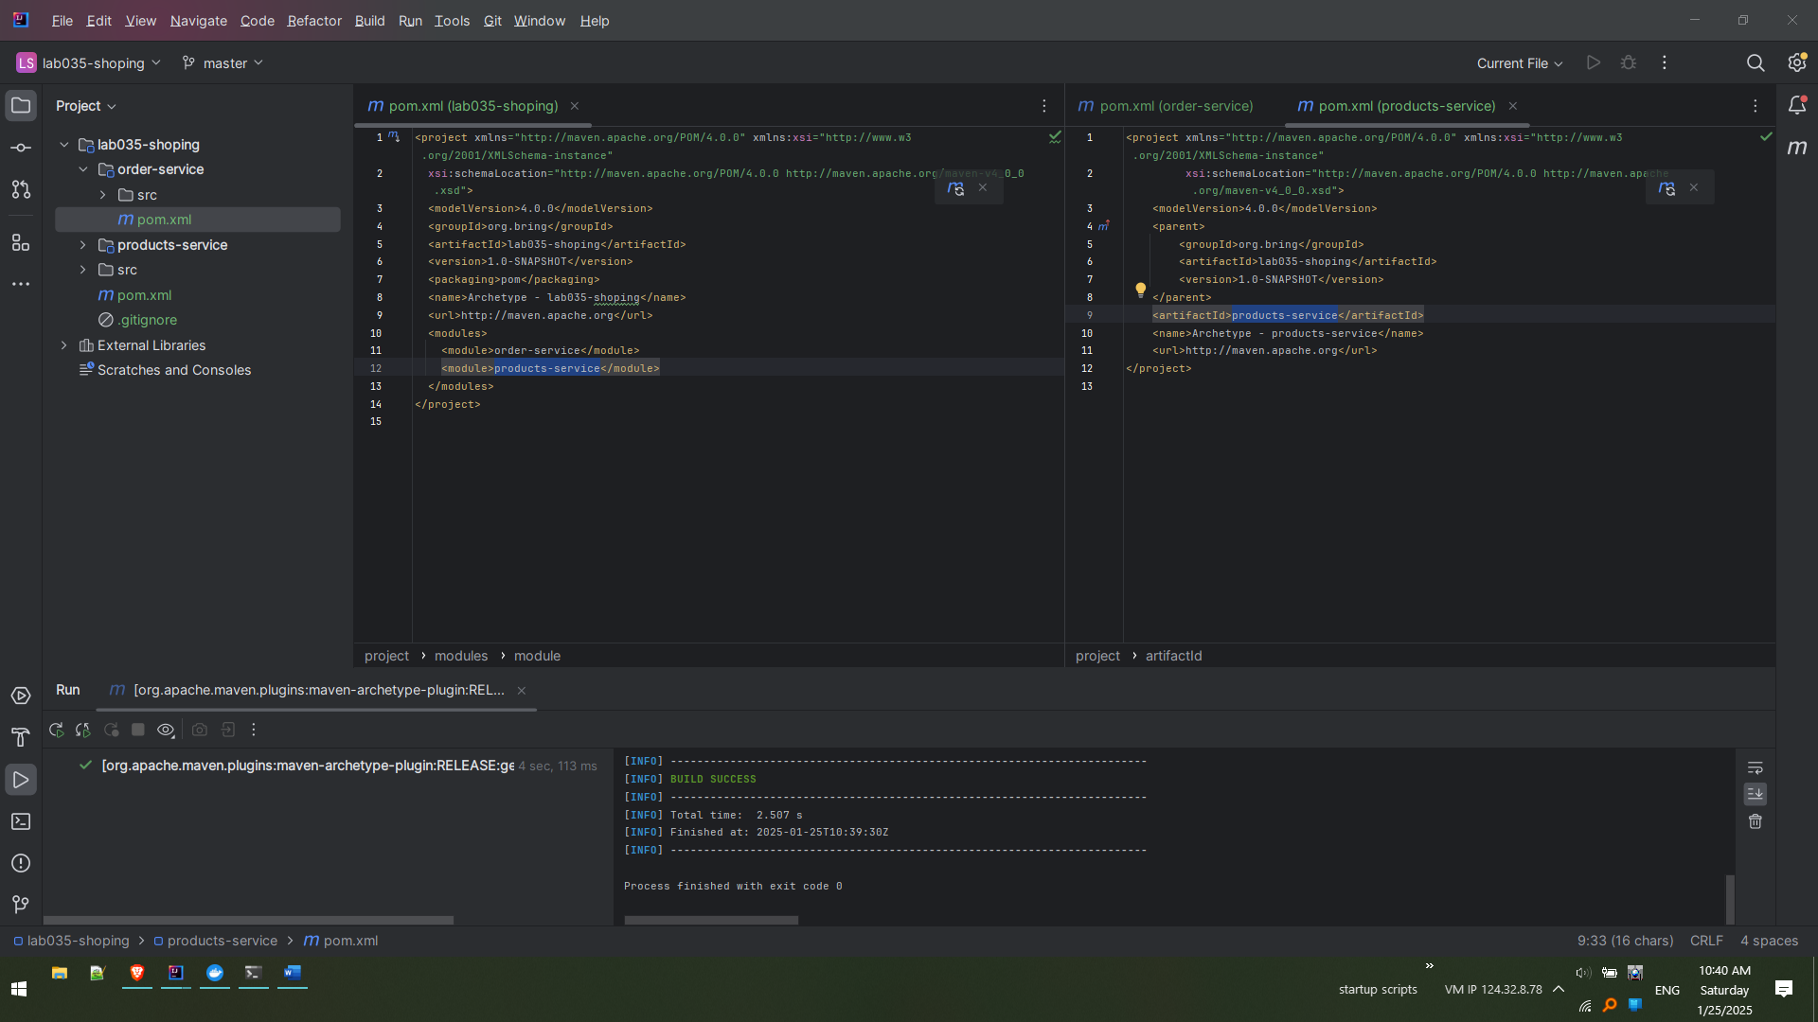

Create new Maven Module – Inventory Service

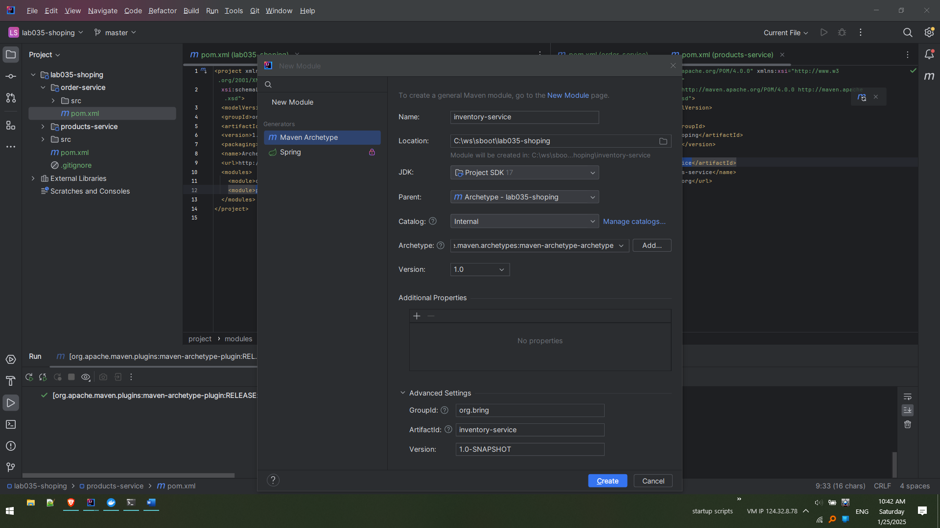

While creation

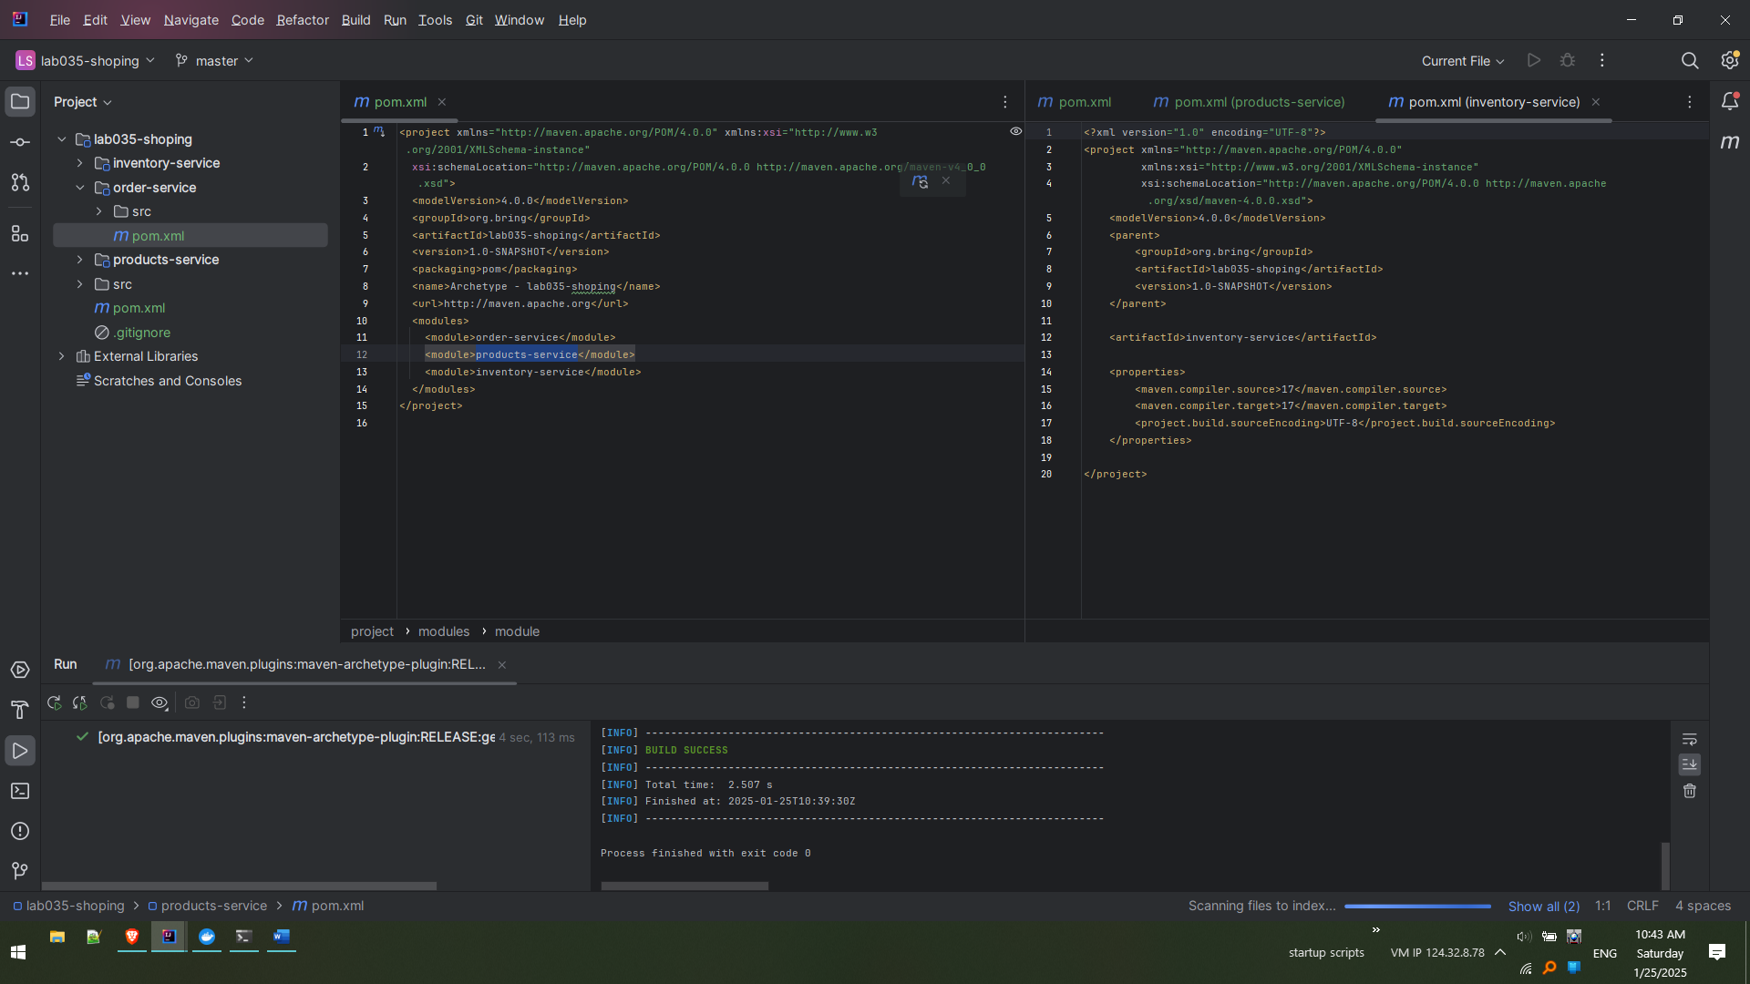

Post creation – Notice the additions to main pom.xml (lab035-shopping)

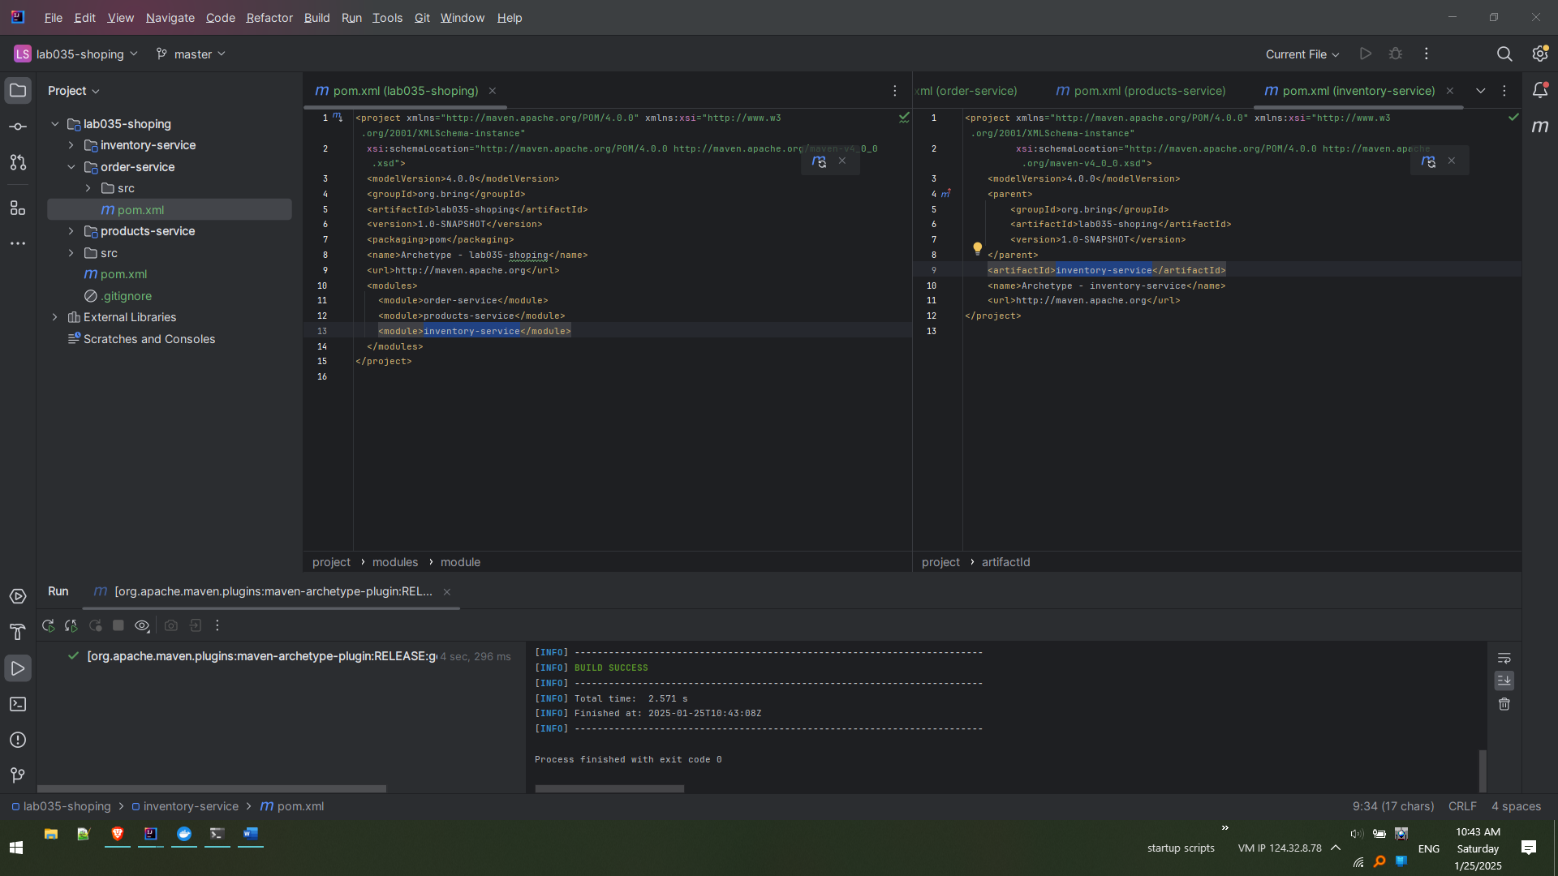

Delete the ‘src’ folder of main project (lab035-shopping)

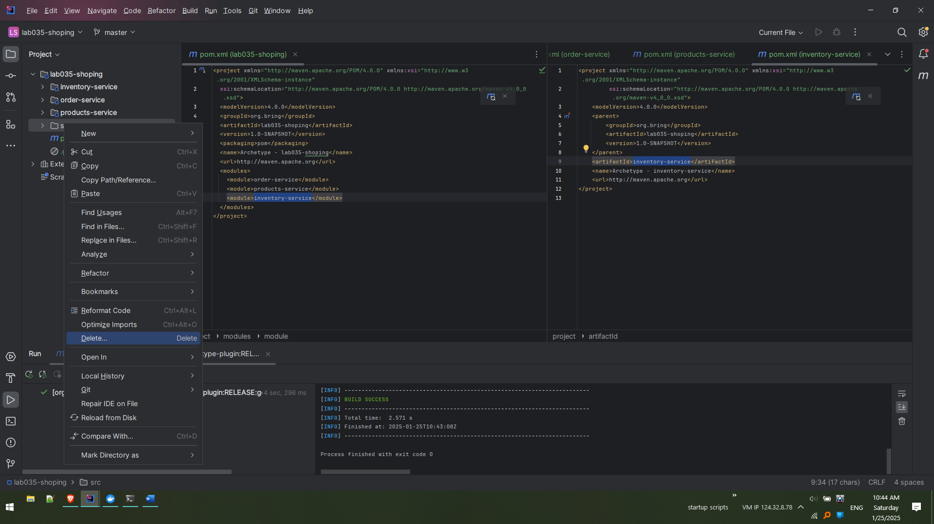

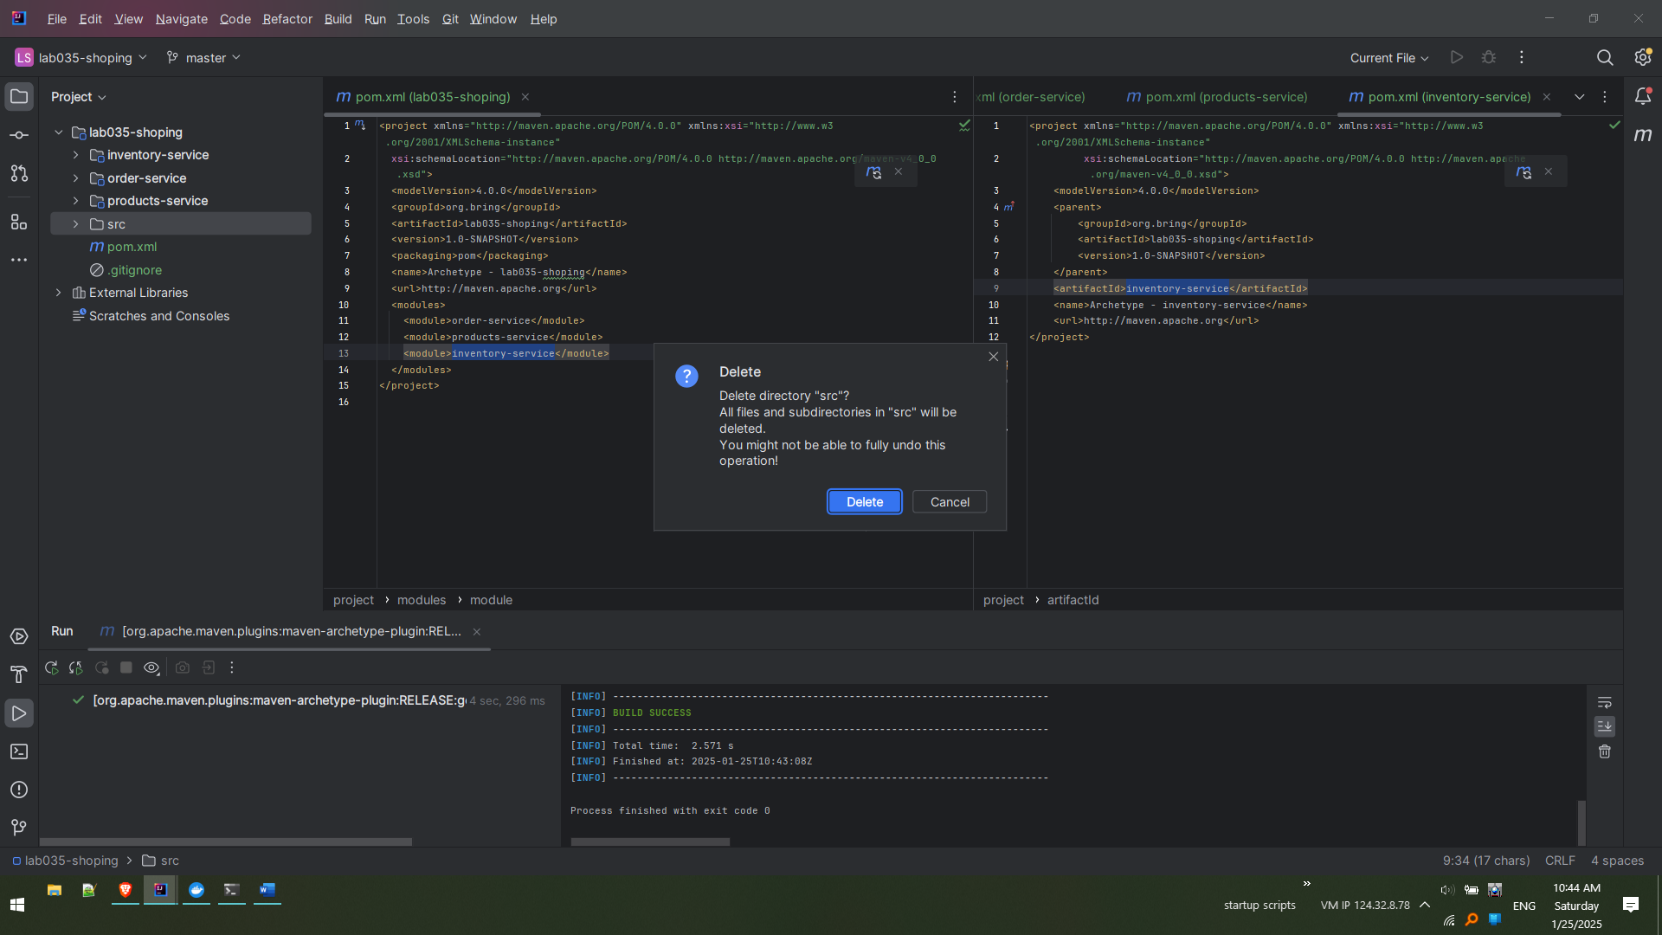 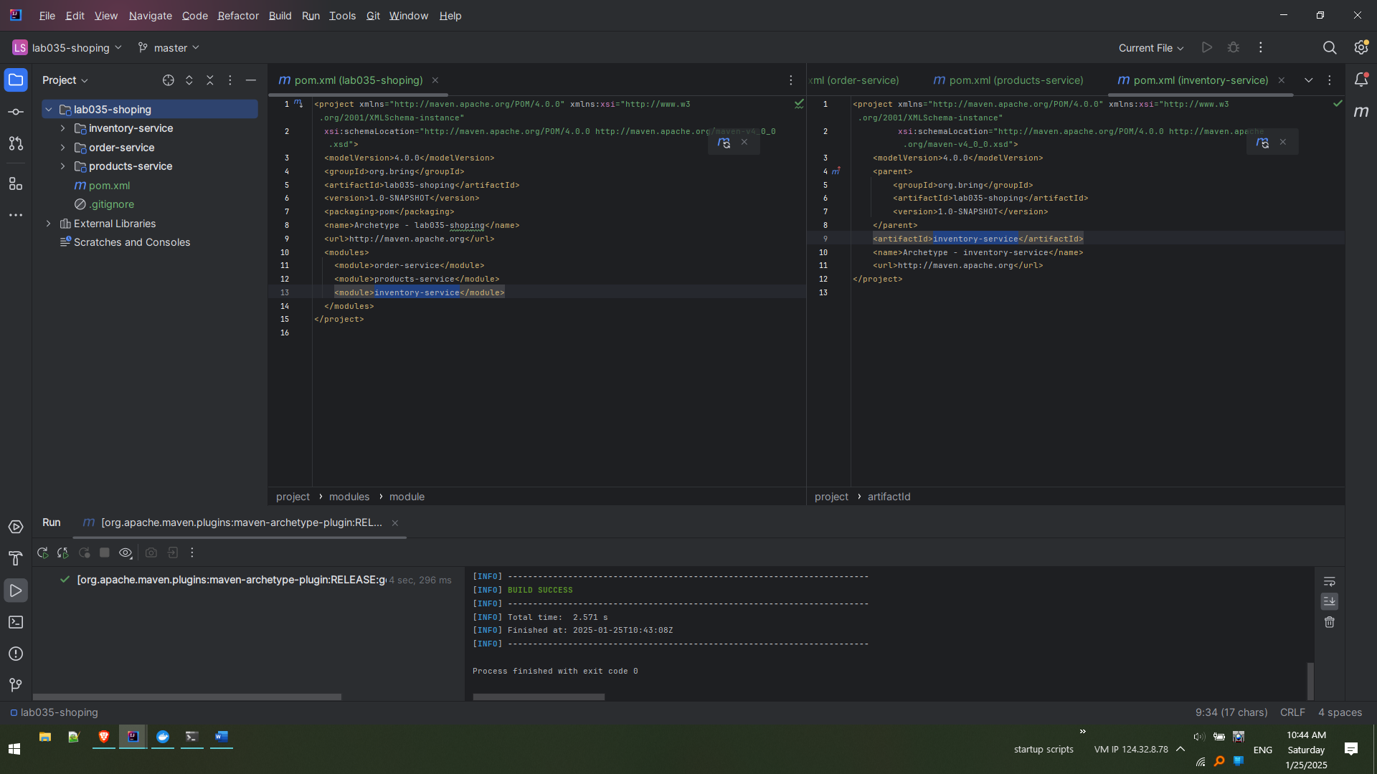

Navigate to other window where projects were created separately.

Copy from Product-service pom.xml all the dependencies and paste as mentioned next.

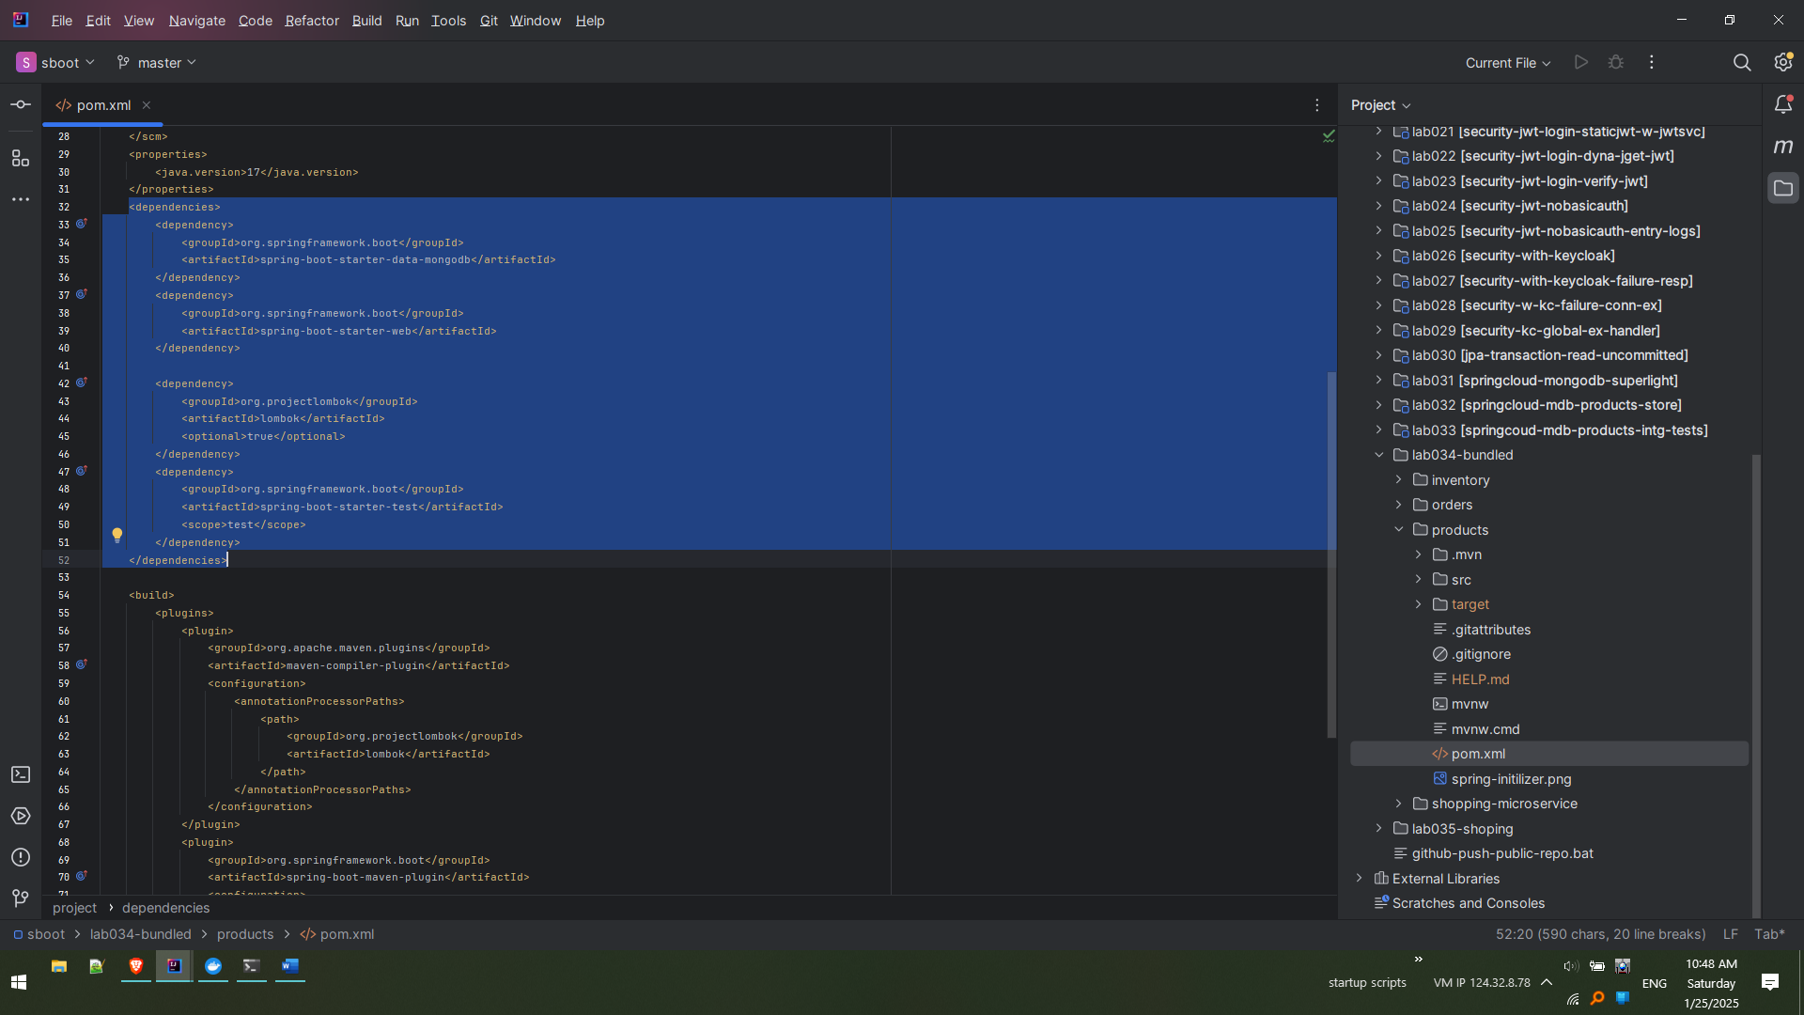

Pasted inside the pom.xml of ‘products-service’. Notice all in ‘red’. This will be solved in next steps.

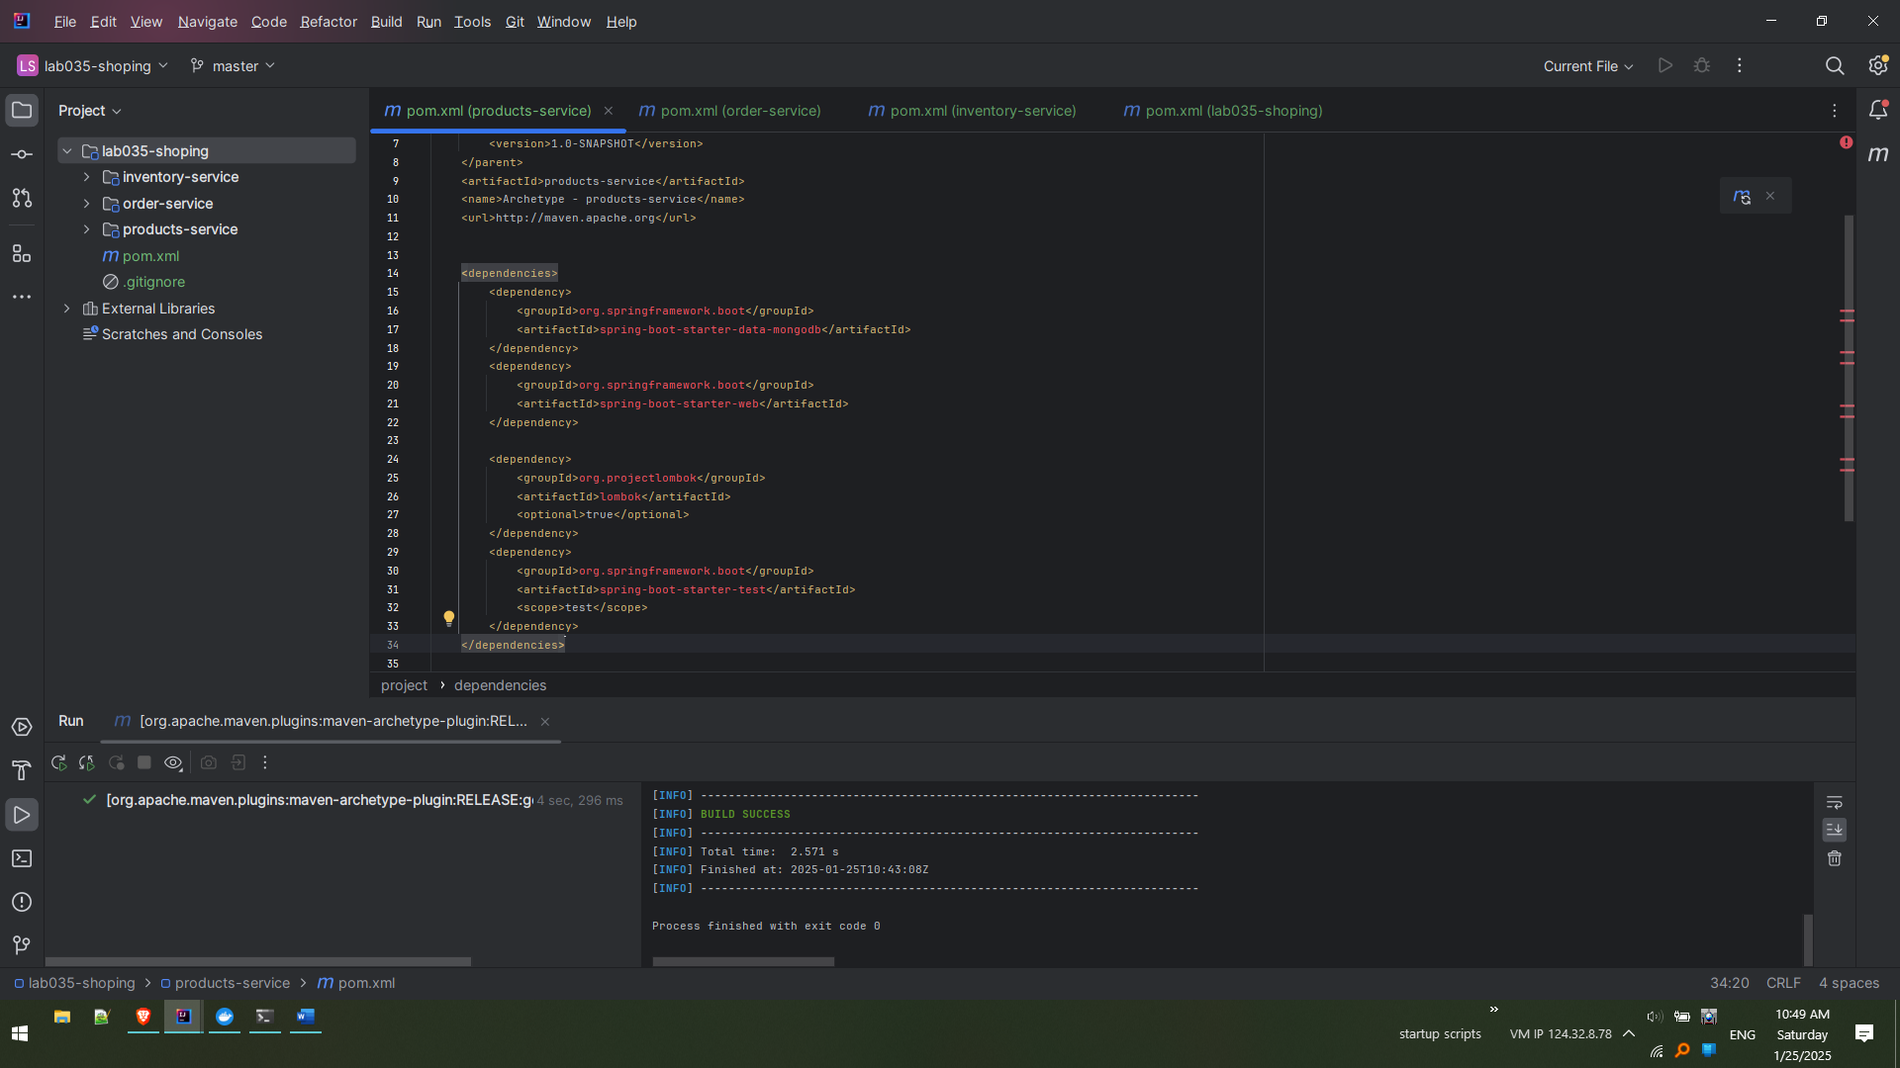

Similarly copy the dependencies of Order-Service and Inventory service (from previously implemented place) to appropriate destinations.

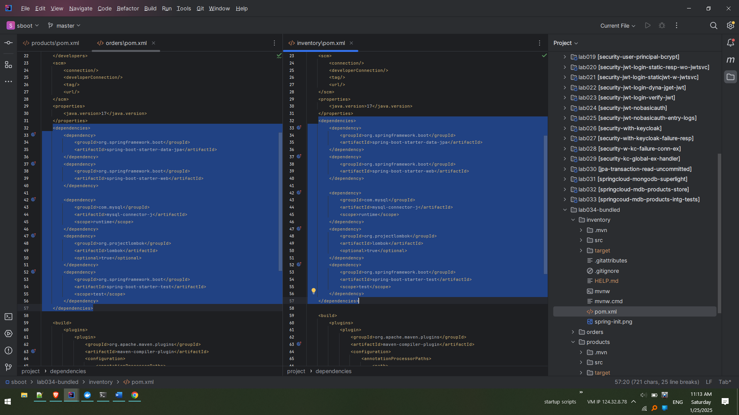

Destinations, after copying. Notice all the pom.xmls have errors.

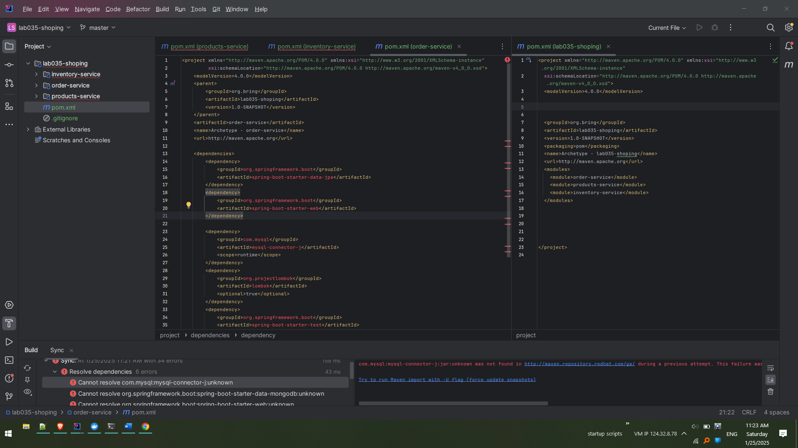

In order to remove these errors the parent pom.xml (lab035-shopping) needs to be updated with parent spring boot definitions or versions. Notice above it does not have.

Copy from any of the services from previous implementation below tag and paste in the destination

For instance highlighted below are parent tag definitions.

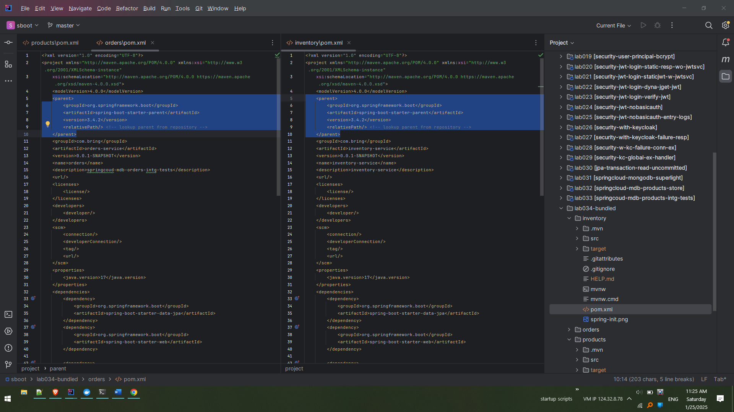

Paste it in the destination under the parent pom.xml (lab035-shopping) and reload the maven changes.

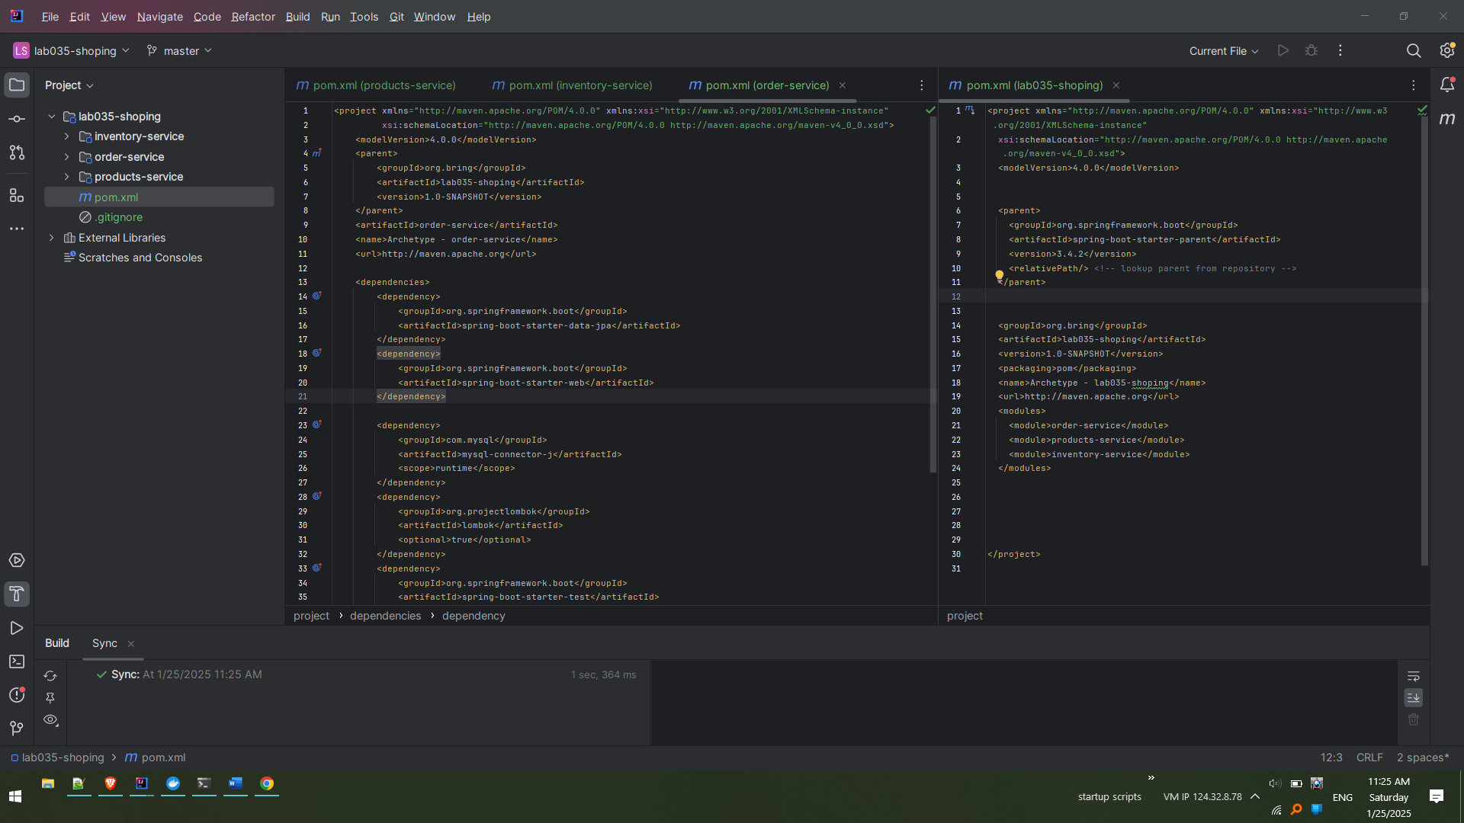

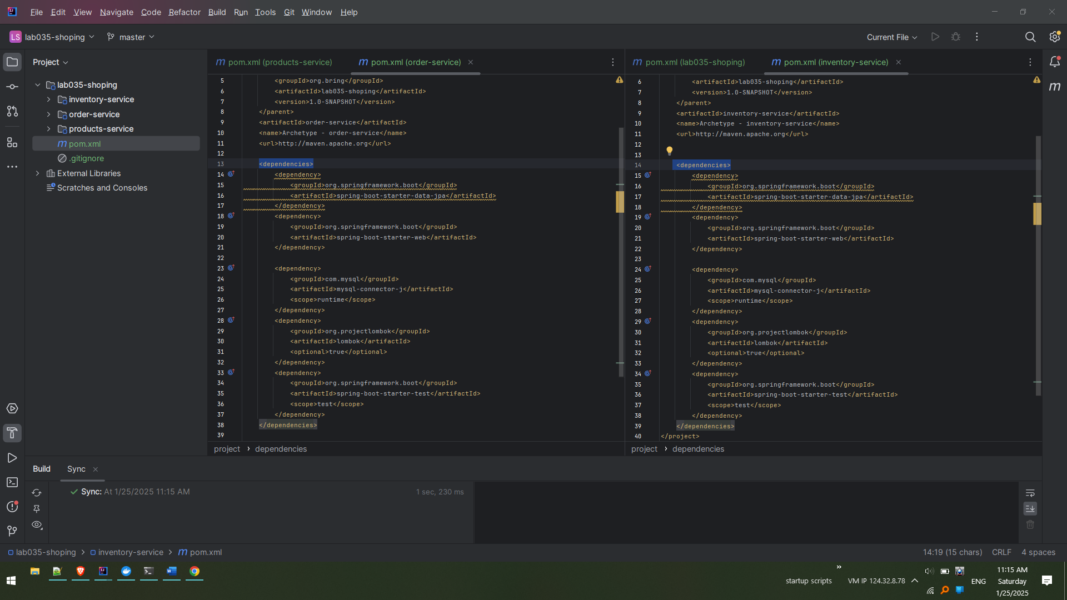

Alternatively this can also be managed using the ‘dependency-management’ tag with below definitions.

<dependencyManagement>

<dependencies>

<dependency>

<groupId>org.springframework.boot</groupId>

<artifactId>spring-boot-dependencies</artifactId>

<version>3.4.1</version> <!-- Use the same version as your original project -->

<type>pom</type>

<scope>import</scope>

</dependency>

</dependencies>

</dependencyManagement>

However, we are using simple approach of having ‘parent’ tag.

Next step is to copy the ‘build’ configuration from any of the old implementations to the parent of new project (lab035-shopping)

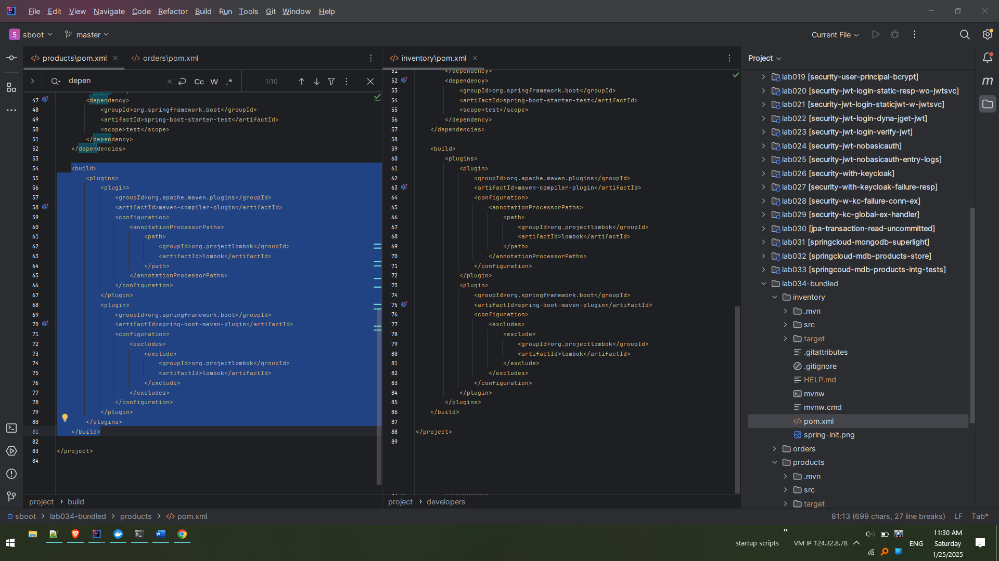

Paste it to the destination as below in pom.xml (lab035-shopping) and load the maven changes.

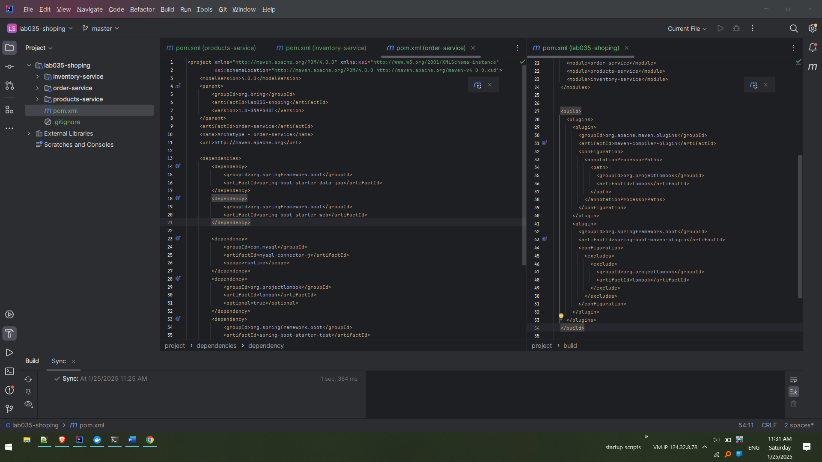

Delete the ‘src’ folders from each of the projects as below. Because we are going to copy from old projects.

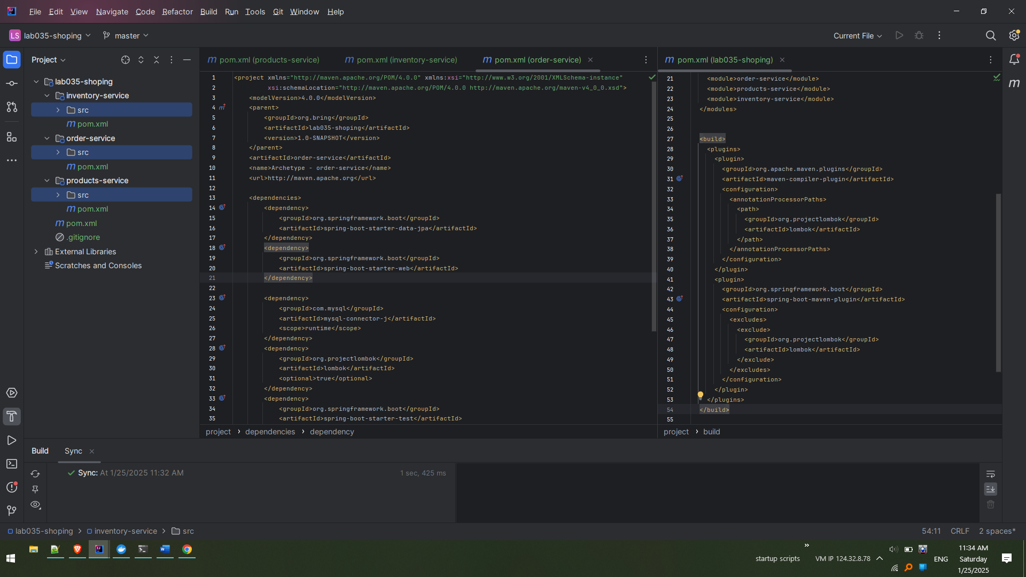

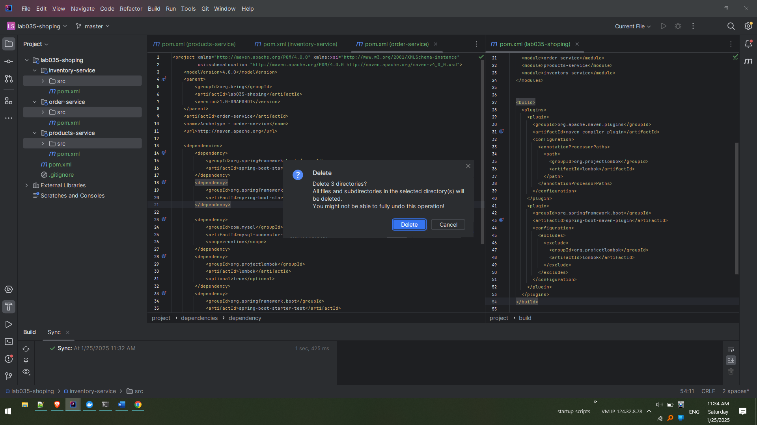

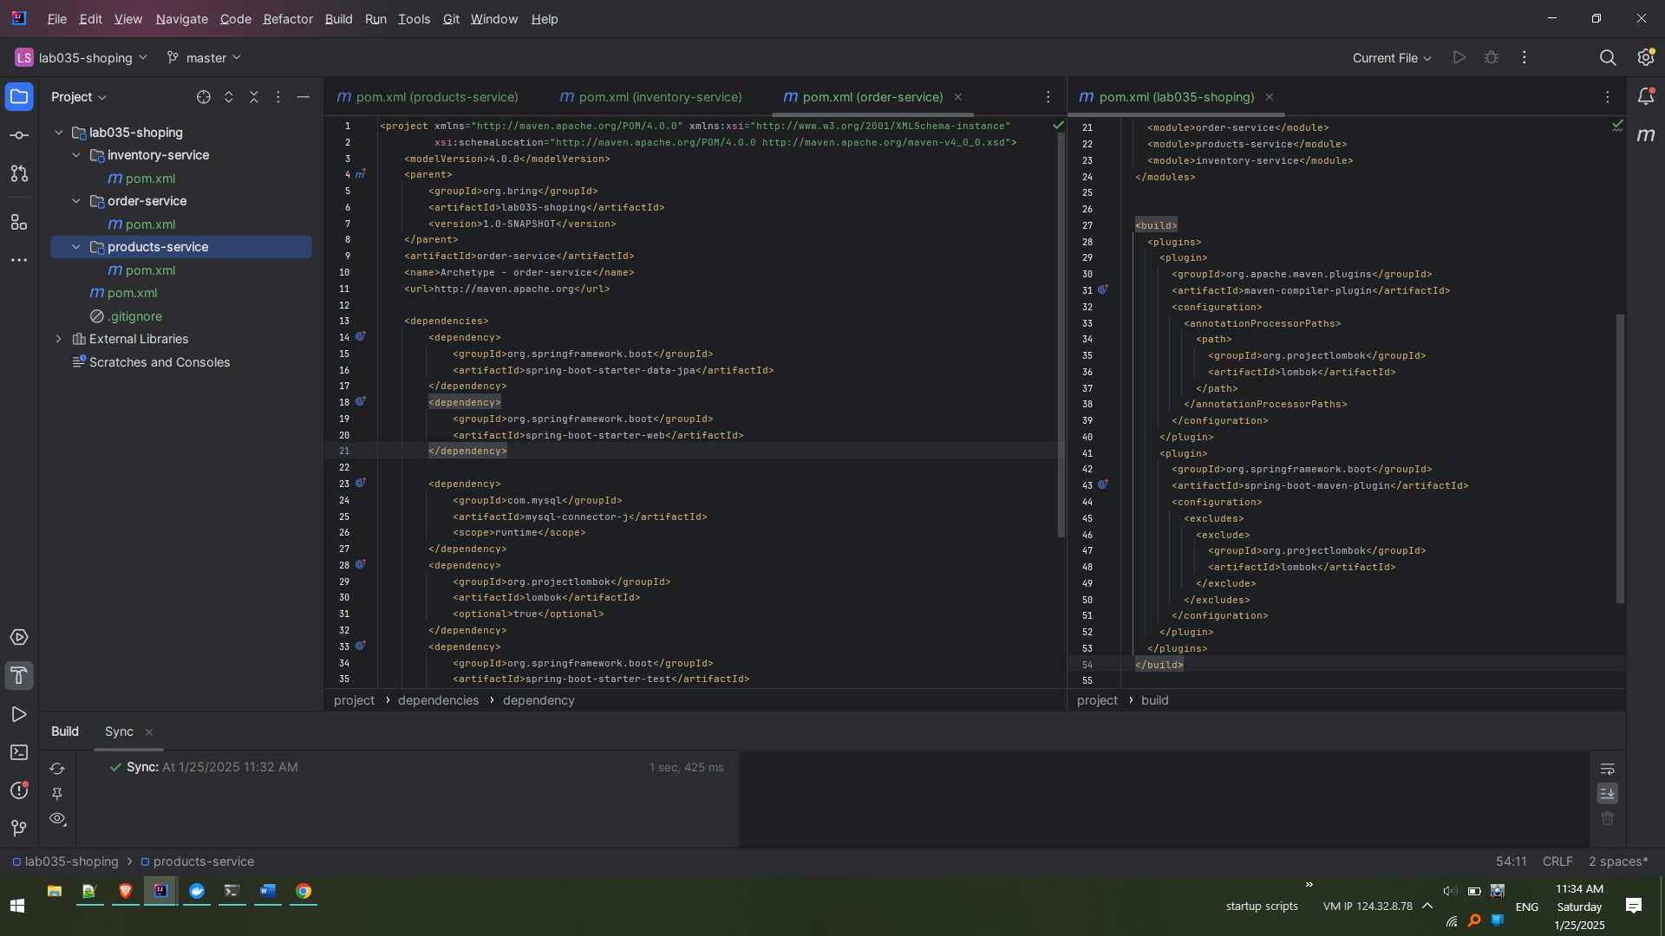

Copy the’src’ from previously implemented service and paste it destination. Notice two src are pasted viz., inventory-service and order-service. In next step products-service is also copied and pasted.

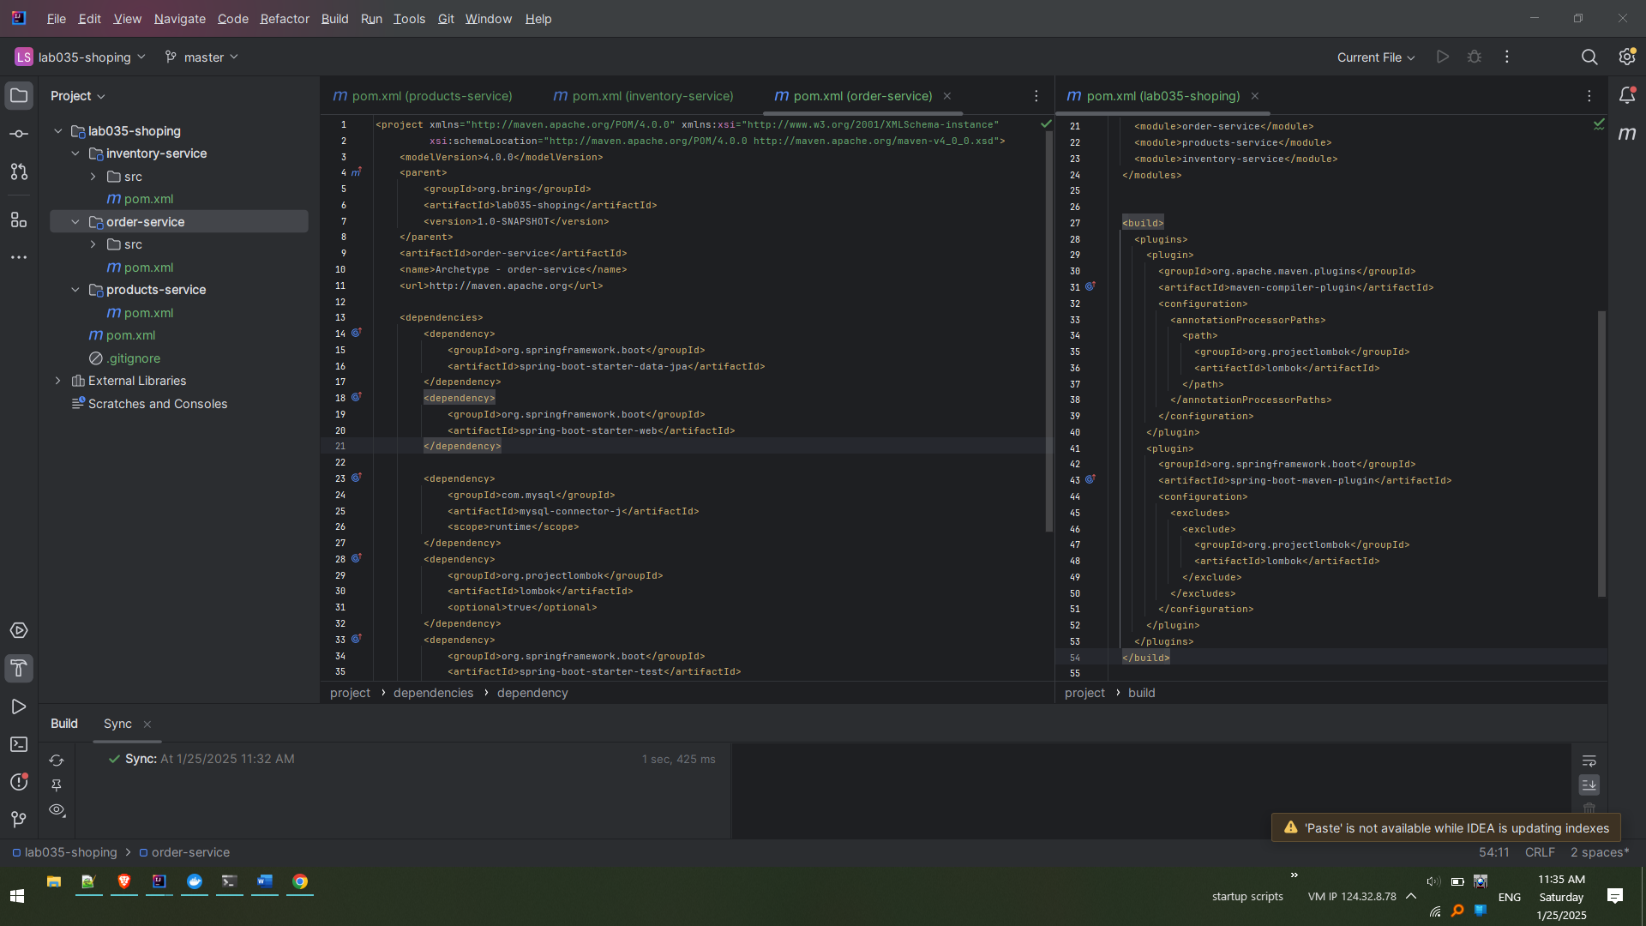

Copy ‘src’ from the products-service (previously implemented)

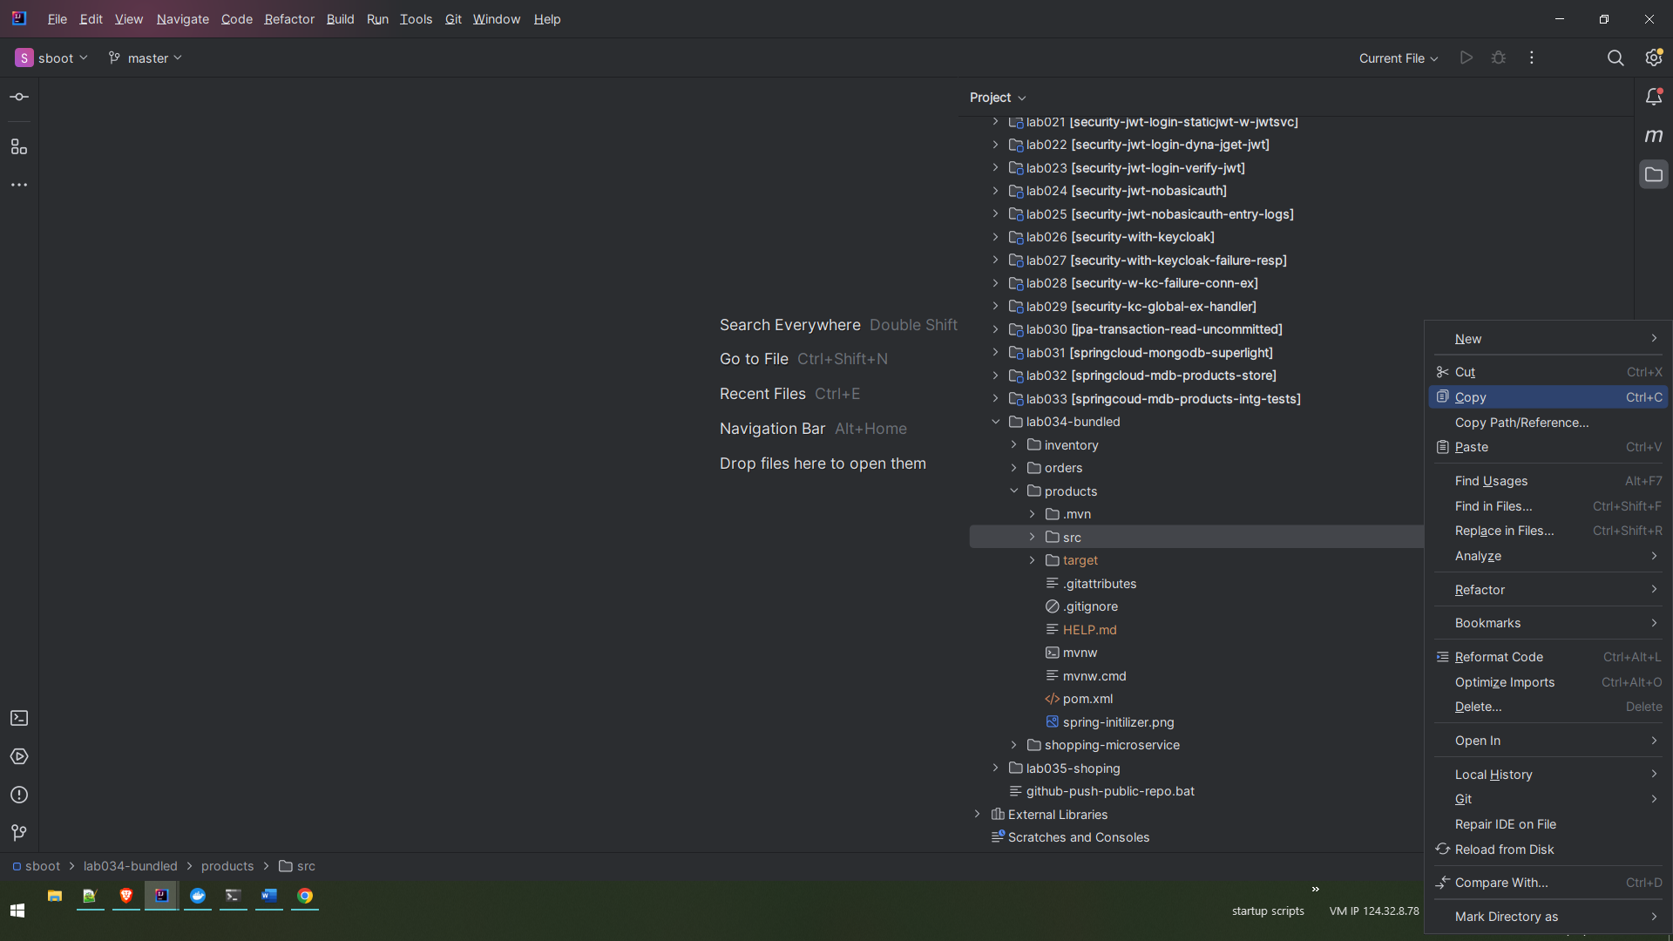

Paste to destination

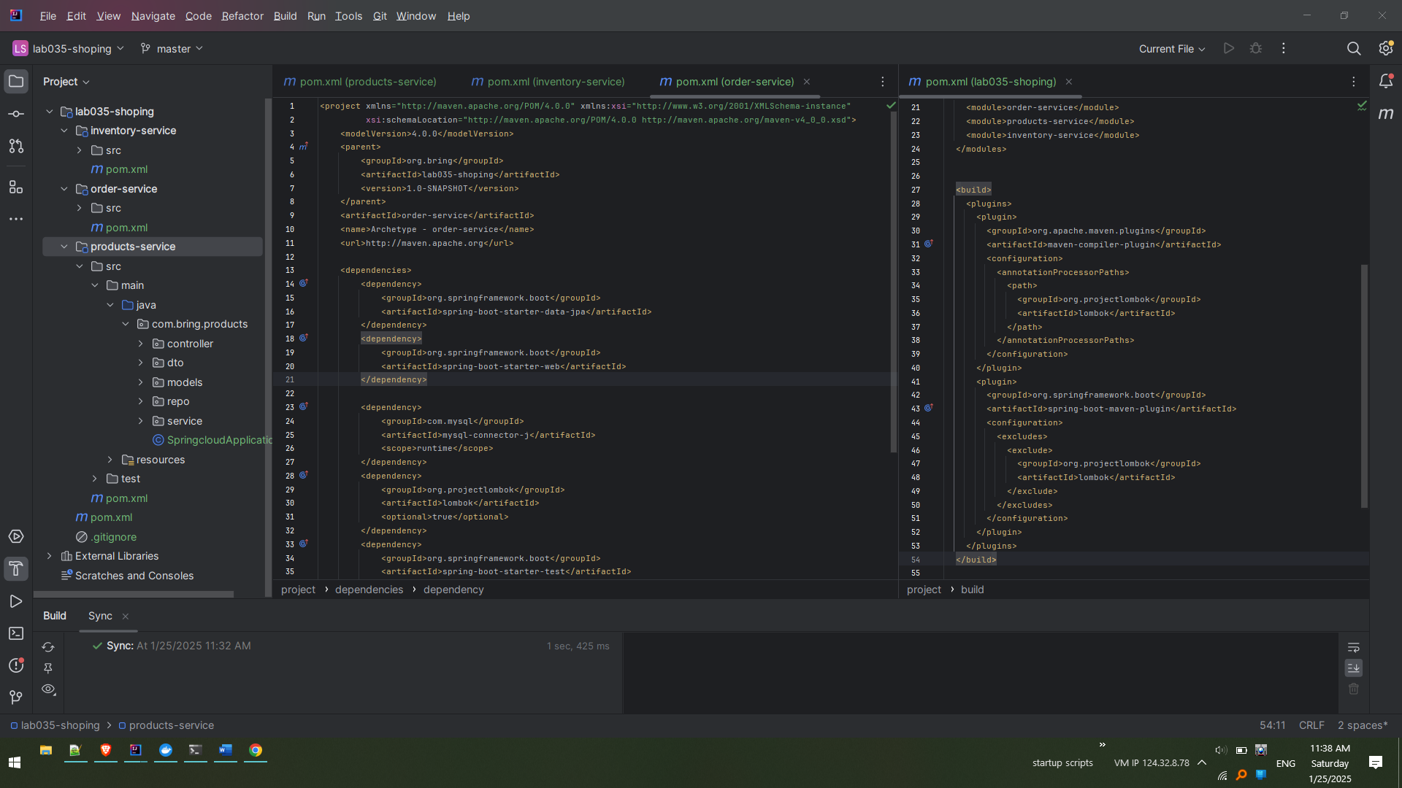

Once copied use the mvn clean verify to see all is well. We will be running the command on the parent pom.xml (lab035-shoping)

Ensure the dependencies like mongodb and mysql are up. Below is snippet where both are running on docker.

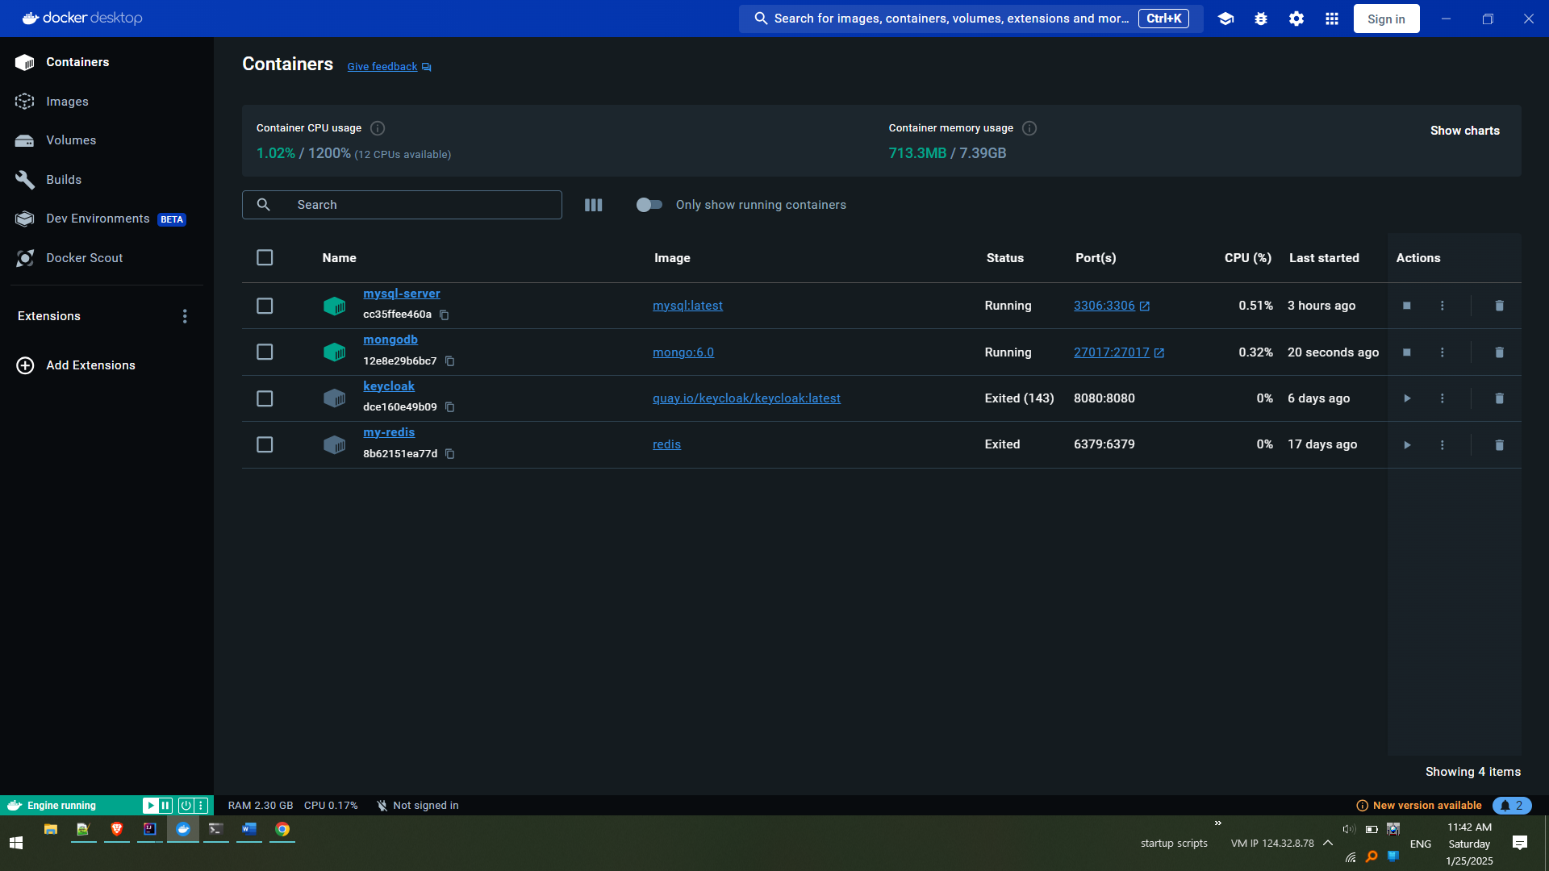

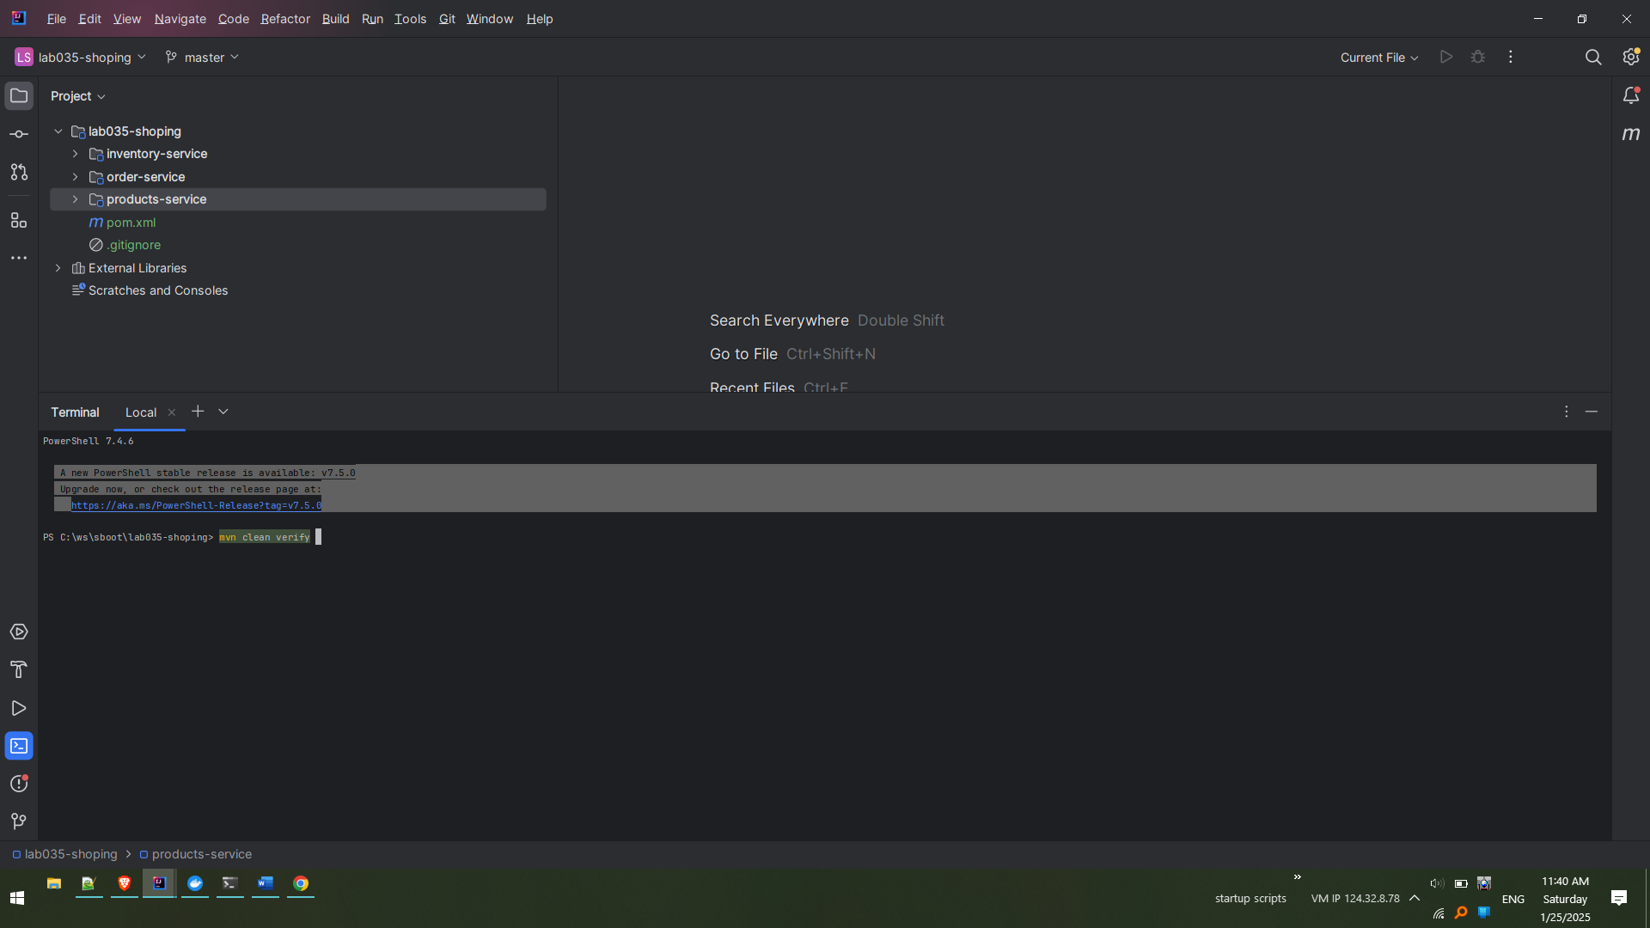

Notice below the build is successful

